***Intro to Java Assignment – 6 UML Diagrams***

**MyPoint class:**

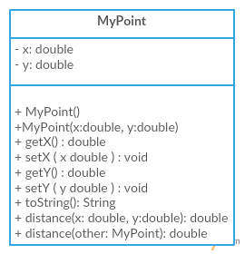

**TheTriangle class which extends GeometricObject class.**

